Finding InDesign on your Desktop

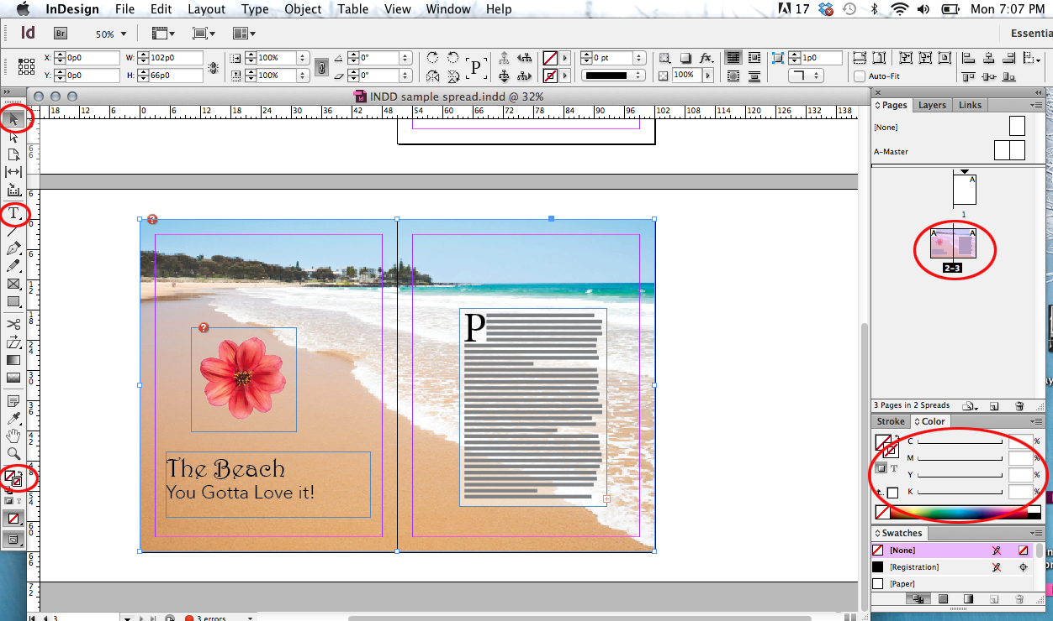
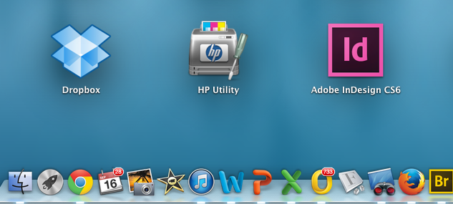
The Indesign (ID) User Interface

Selection Tool: allows you to select items on the pasteboard.

Type tool: Allows you to add text.

Pages: a diagram of all the pages in your document. You need to have 3 page so that pages 2 and 3 are next to each other.

Fill Color: Fills a shape with color
Stroke Color: Puts a colored border around a shape.
To Find InDesign go to the Launch button on your dock (usually at the bottom of the page). Look for the Id pink and black button. It might be on the first desktop page or the second.
Creating an Editorial Spread (2 pages next to each other) in ID
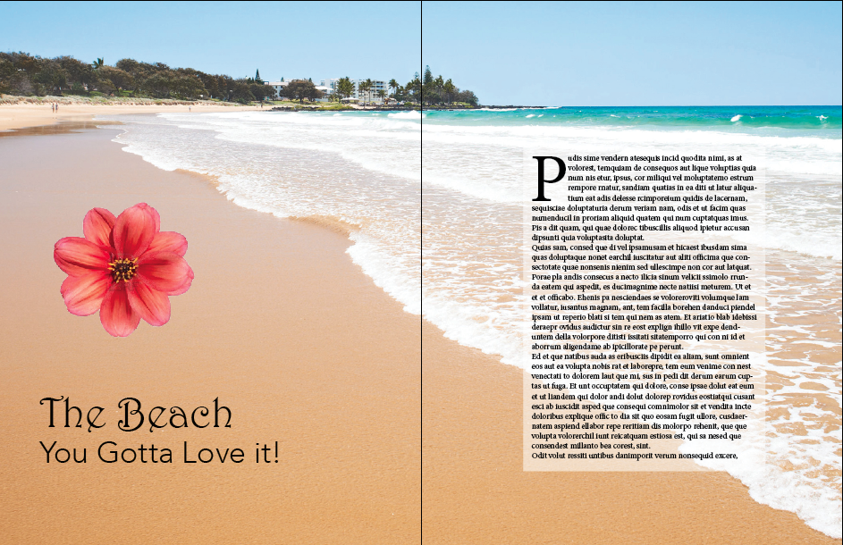 | What you are creating:  In order to learn how to use InDesign to create your profile article follow the steps here for the basics you will need to know.  After this, experiment, explore, look things up and design an interesting looking article.
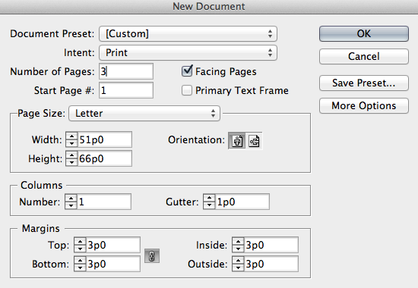 | Step 1: Open Indesign  Step 2: Create a new document using the settings in the image on the left.  Your document will be on regular “letter” size paper and it will be portrait orientation.
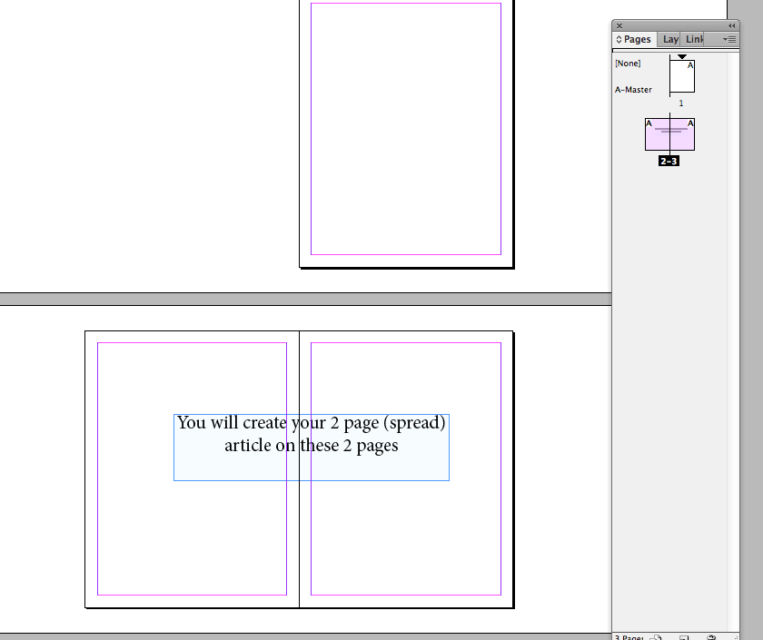 | Step 3: Indesign will create 3 pages. You will only be working on the 2 pages that are next to each other as in the image on the left.  Adjust your page size by zooming in and out.  Enlarge your page view: command +  Reduce your page view: command –  (the same as in the other programs.)  You can see a mini-view of your pages on the floating palette on the right.
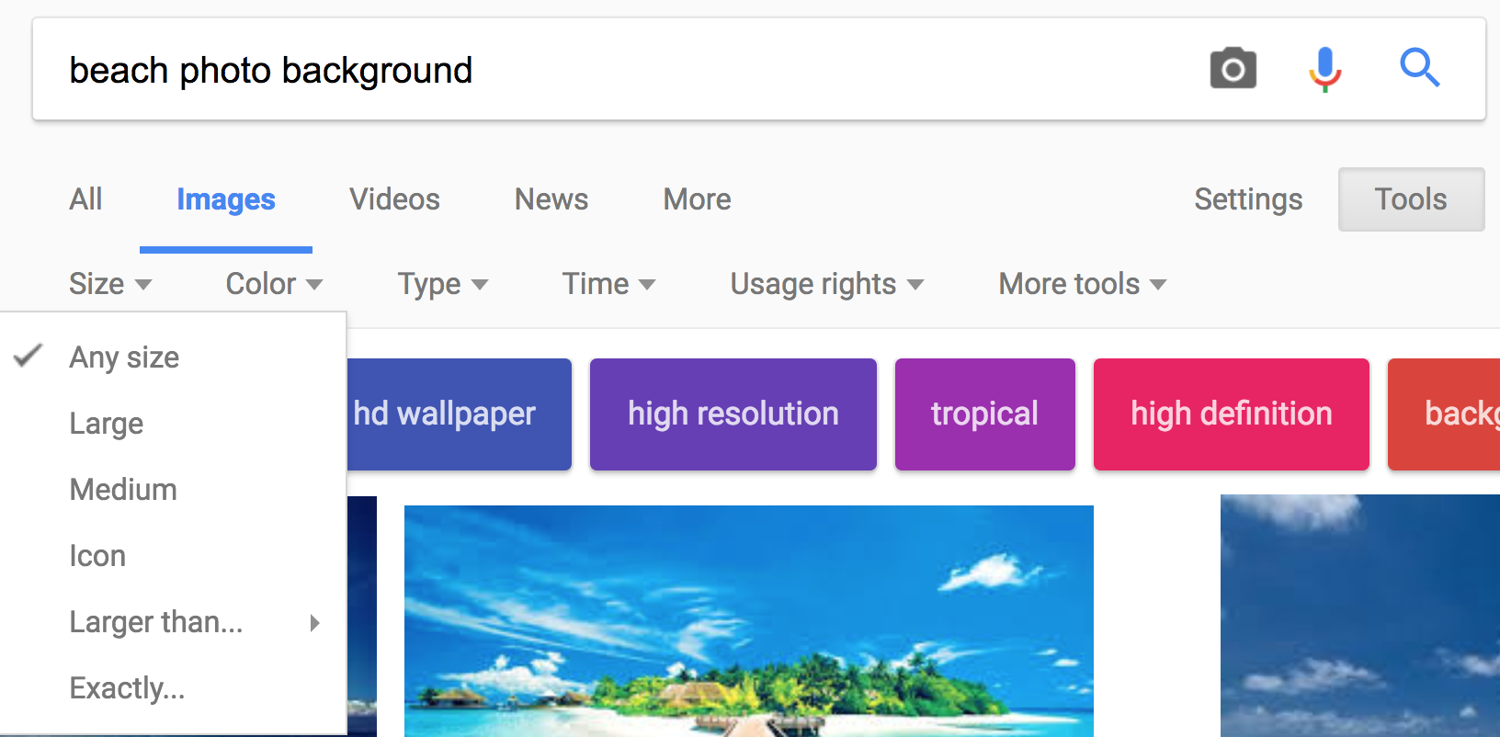 | Step 4: Find a large resolution background image on Google. Type in “Beach photo background”  (You do not have to find the background image that I used but you can if you want.)  Click the tools button on Google, and then it will give you the option to choose the image sizes available within the search bar.  Find a high resolution beach photo and save it to your desktop.
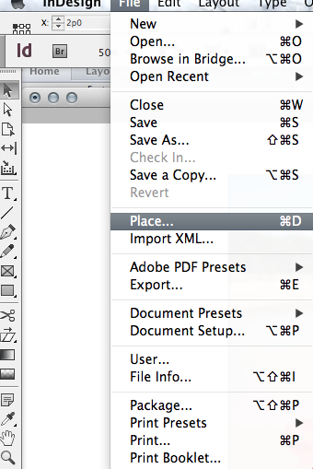 | Step 5: In ID, go to File>Place (see left) and find the background image you saved on your desktop.  Place your image at the very up left of your page and click.  Your image will probably run off the page. In the next step you will learn how to resize it.
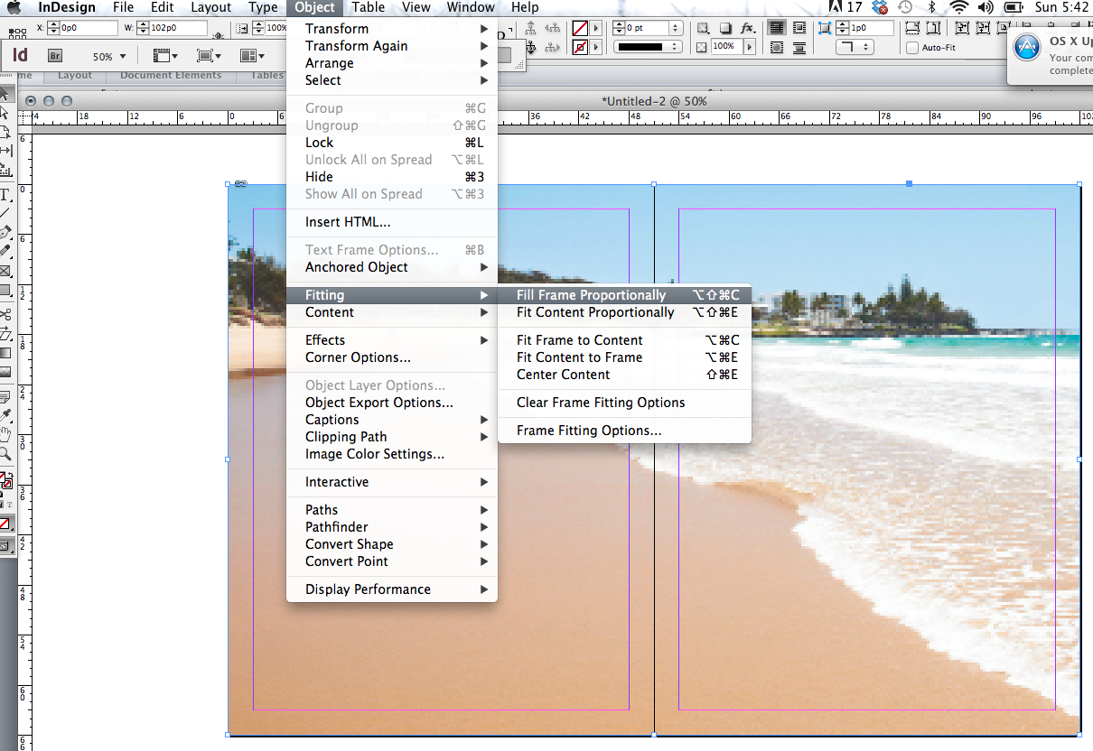 | Resize your background Photo  Step 6: Resize your background.  Using the black arrow tool, grab the bottom right corner and bring it up to match the outside rectangle of your pages.  Your image WILL NOT RESIZE like it does in Word. That’s ok.  Go to: Object>Fitting>Fill Frame Proportionately (see left)  This will make your background fit inside your two page spread without warping its proportions and stretching it.  **Make sure to save your document Often  If your background photo looks pixelated or blurry see the instructions of page 8 of this document.
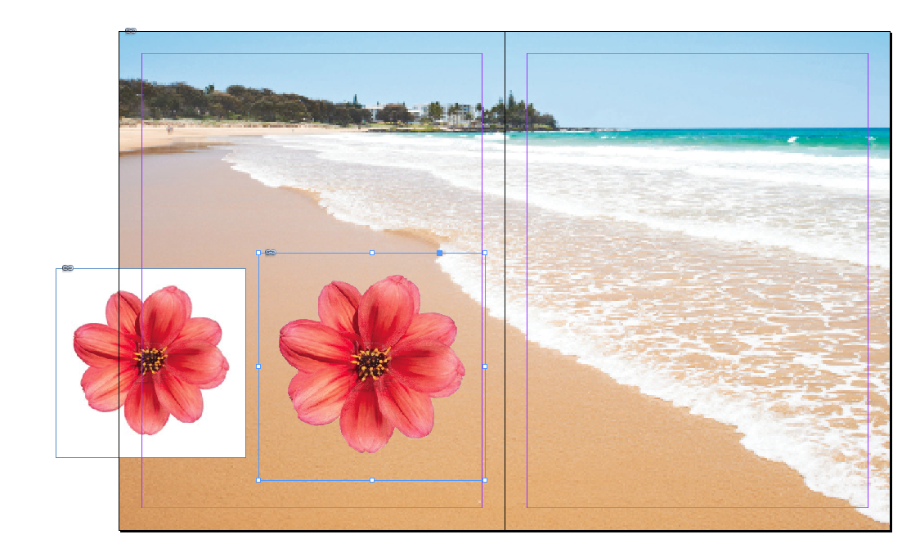 | Cutting out Backgrounds in Photoshop  Sometimes you will want to use an image—but not it’s background. This is when designers may use more than one program.  Photoshop is the best way to cut out backgrounds. Images that are against a white background (see left) are the easiest.  Open your image of a flower in Photoshop (yes, we are going to switch programs really quick).  Unlock the background image by double clicking on it (then selecting OK). This allows you to remove the background pixels. Use the magic wand tool and select the white background then click delete. (you guys are more advanced and know how to use masks, but for the sake of this tutorial we will make life easy and just simply delete the background).  Make sure to save your flower document as a .psd so that it preserves the transparent background. DO NOT save it as a .jpeg right now because that will get rid of the transparent background.
Switch back to Indesign.

File > place > and select the .psd file of your flower.

The background will not be there like in the image on the left.
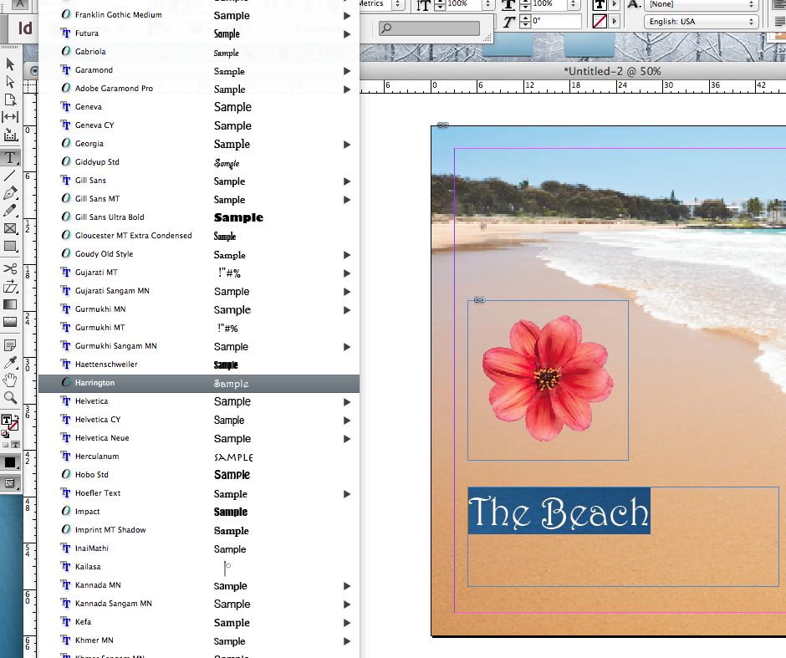 | Adding Text  To add a text box to your layout, choose the “T” text tool. You can use the keyboard shortcut and press the letter “t” on your keyboard and it will automatically turn your cursor into the Text tool. Click and drag to draw a box where you want your text to be.  Type the words  “The Beach you gotta love it”  into your text box.  To change the type size and style you can find all the options in the type palette at the top of your screen.  To change type size you can also use the keyboard shortcuts:  Bigger type: Command/shift and >  Smaller type: Command /shift and <  To change the color, highlight the words you want to change and double click on the color picker at the bottom of the tool bar to choose a new color. The square with the T must be on top.
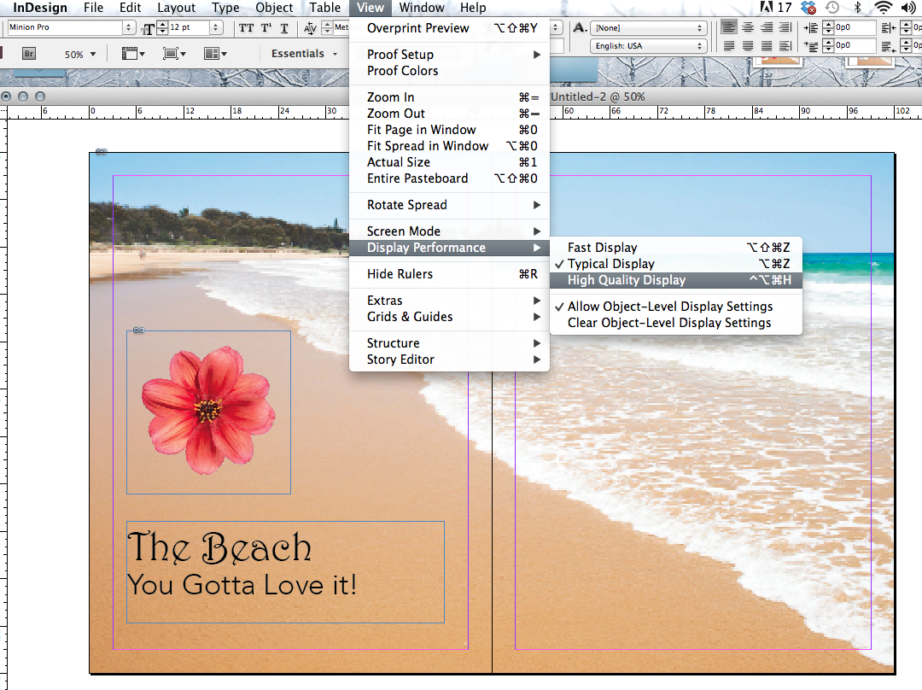 | A Note about the Appearance of your Background Image  If your background image seems very pixilated or blurry, that is because InDesign does that so that you can work faster. The program runs faster when it doesn’t have to show a crisp clear image for everything.  If you want to change the display so it’s not pixelated anymore, go to:  View>Display Performance>High Quality Display (see left)  This will make your background image look much better provided is big enough to begin with.  It’s best to work in “typical display” mode because the program runs faster. But it’s nice to be able to turn on “high quality display” every once in a while to get a better feel for how your work really looks.  **Make sure to save your document Often
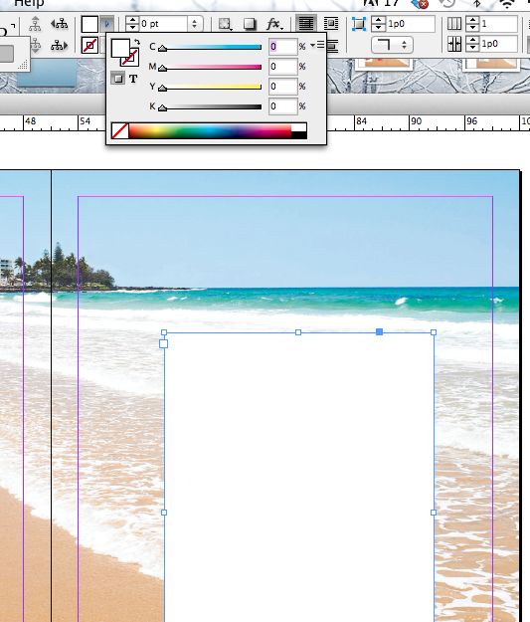  Use the shift key to get this box | Creating a Text Box for the Words of your Article  All text will be in a text box. A default text box will always be clear so that you can see through it, but if you are putting text on a photo, you might need to make your text box a color so that you can more easily read your text.  Using the “T” tool on the left bar, draw a text box where you want it  Now, switch out of the T tool and back to the black arrow tool (the direct selection tool). You can do this by simply pressing the letter v on your keyboard.  You will see a box at the top of your screen and if you hover over it, it says “fill.” Double click it and choose a color (I chose white). You can scroll through all the colors of the rainbow.  Now you have a white box to put your text into.  **Make sure to save your document Often
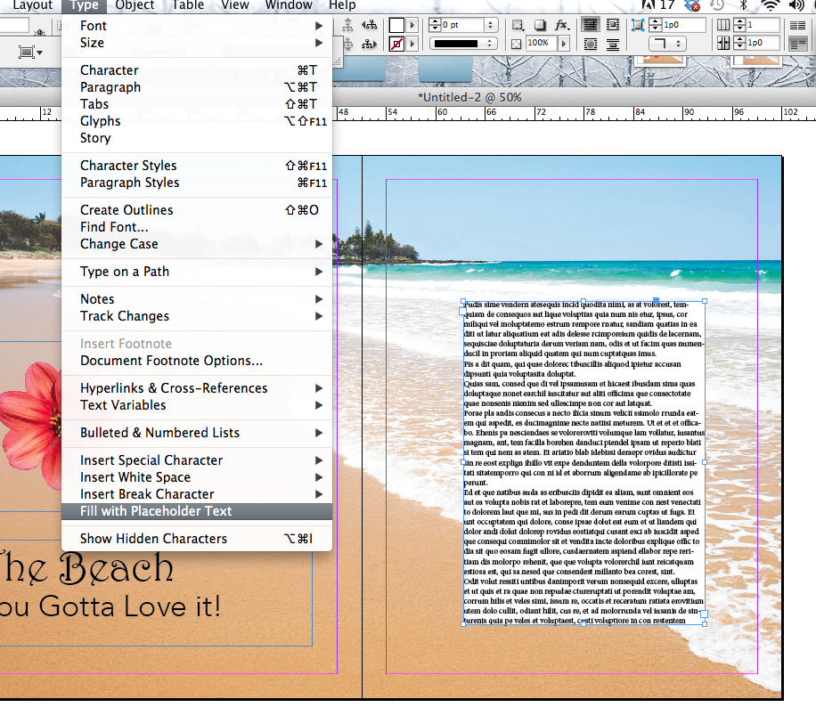 | Add Placeholder Text to your Page  Designers often need to do design work before they have actual words (called copy). When this is the case they add Placeholder text. To do this  Select your text box and go to Type>Fill with Placeholder text (see the drop down box on the left)  This will fill your text box with nonsense text to just give your page the “look” of having text.  This dummy text is called “lorem ipsum” based on greek gibberish!  **Make sure to save your document Often
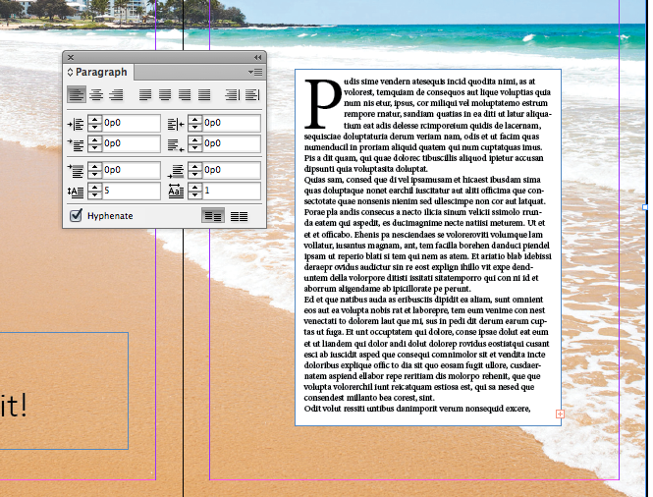 | Add a Drop Cap to your Page  To make the large P like on the left, go to the very top of you screen click  window > types and tables > paragraph  You will get a floating box like on the left. In the bottom box on the left, type in the number of lines you want your Drop Cap to take up. I made mine 5.
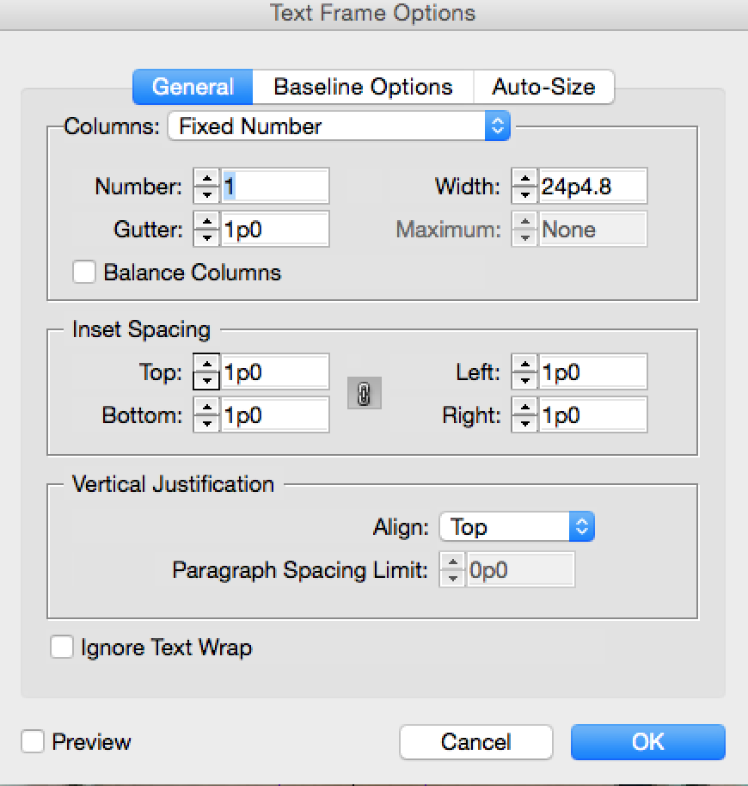 | Pull your text away from the edges of the box.  You never want your text to touch the edge of a box so you are going to use Inset Spacing to create this space.  Select the text box with the black arrow tool. Then right click on the box OR use Command + B which is Text Frame Options. In the menu make all the Inset Spacing margins to 1p. This means 1 pica, which is a design measurement that is a little less than ¼ inch.
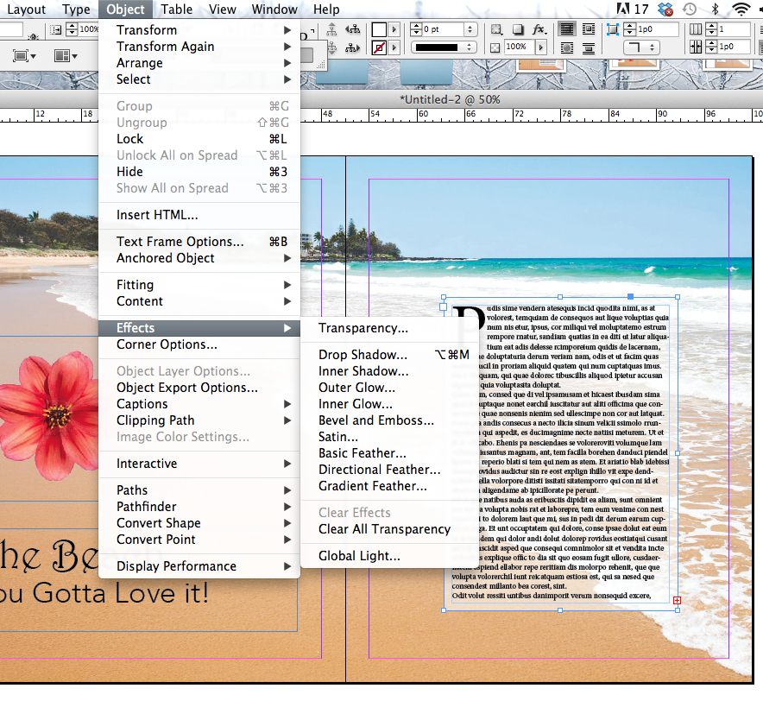 | Making Your Text box a Little Bit  Transparent  Sometimes you might want to see a little bit of the background image through your text box. To do this go to Object>Effects>Transparency. Choose “Fill” in the Settings For: box and then change your Opacity to a percentage. 50% would be half transparent. I suggest something like 60% so that you can see the waves but yet your text is still readable.  **Make sure to save your document Often
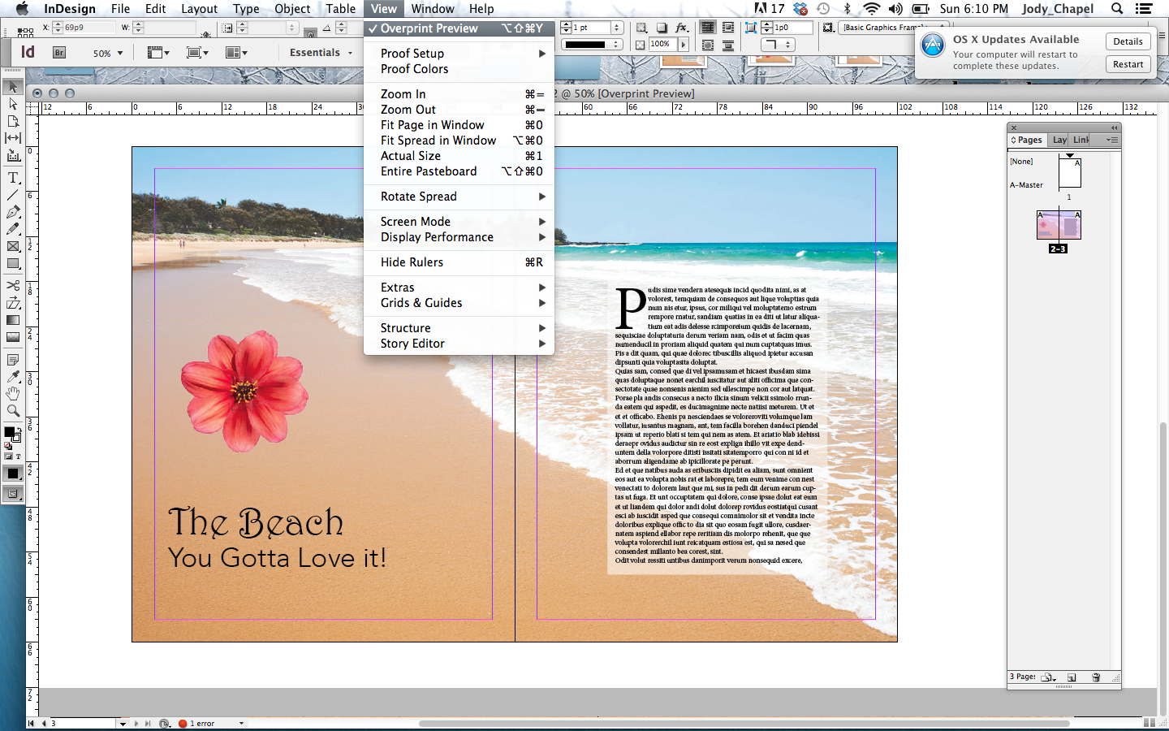 | See What Your Image Looks Like  Now you will want to see your pages without all the guidelines.  - View>Overprint Preview  - View>Grids & Guides>Hide Guides  You are all done!  To turn in your document, please save it as a .PDF  To do this, go file > export > adobe PDF (print)  Make sure to save your document to turn in.  title it:  YourName_IDtutorial.pdf  Upload your practice document into Google Classroom to get credit for your hard work!

