Filling Text with an image

Step 1
With the text frame selected (use the Selection Tool (V, Escape)), go up to Type on the top menu, and select Create Outlines.
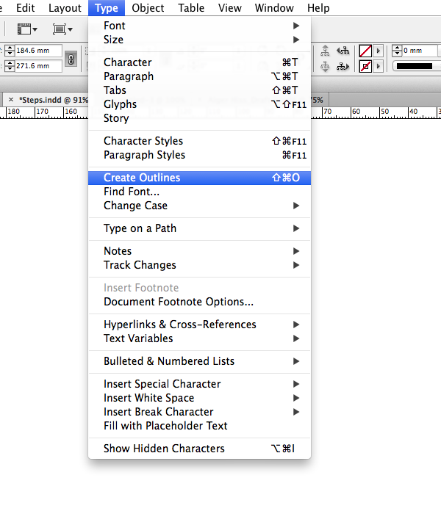
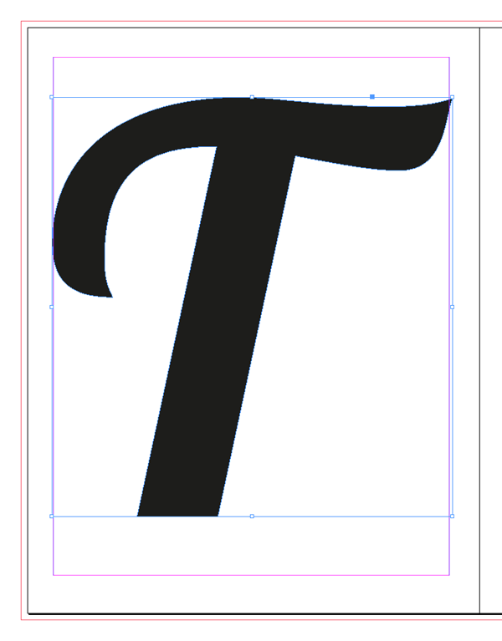
The text frame will subtly adjust; the text character has now been converted into a vector shape.

Step 2
With the character still selected, head up to File > Place.
Now you can start to experiment with filling your text with images. If you’re setting your text on a white or pale background, look for a photo that’s going to provide enough contrast, and vice versa if you want to work on a darker background.
Here I’ve experimented with this image of a fashionable woman, before finally deciding on an image of a blue, cloudy sky.
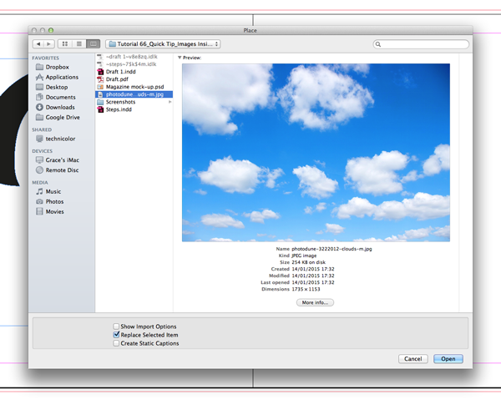

To adjust the size of the image inside the text, double-click to select the image directly, and then hold Shift and drag one of the corners to resize. If you want to fit as much of the image as possible in the letter, head up to the Controls panel running along the top of the workspace and click the Fill Frame Proportionally button. Or go to Objects>Fitting>Fill frame proportionately.

Step 3
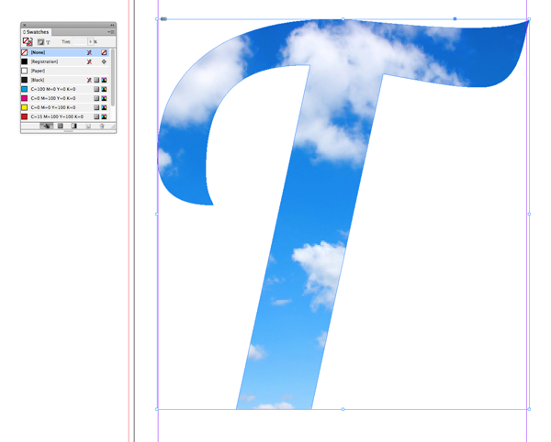
As a final touch, to ensure no color bleeds through on the edges of the letter, open the Swatches panel (Window > Color > Swatches) and set the Fill of the shape to [None]. That’s it!

